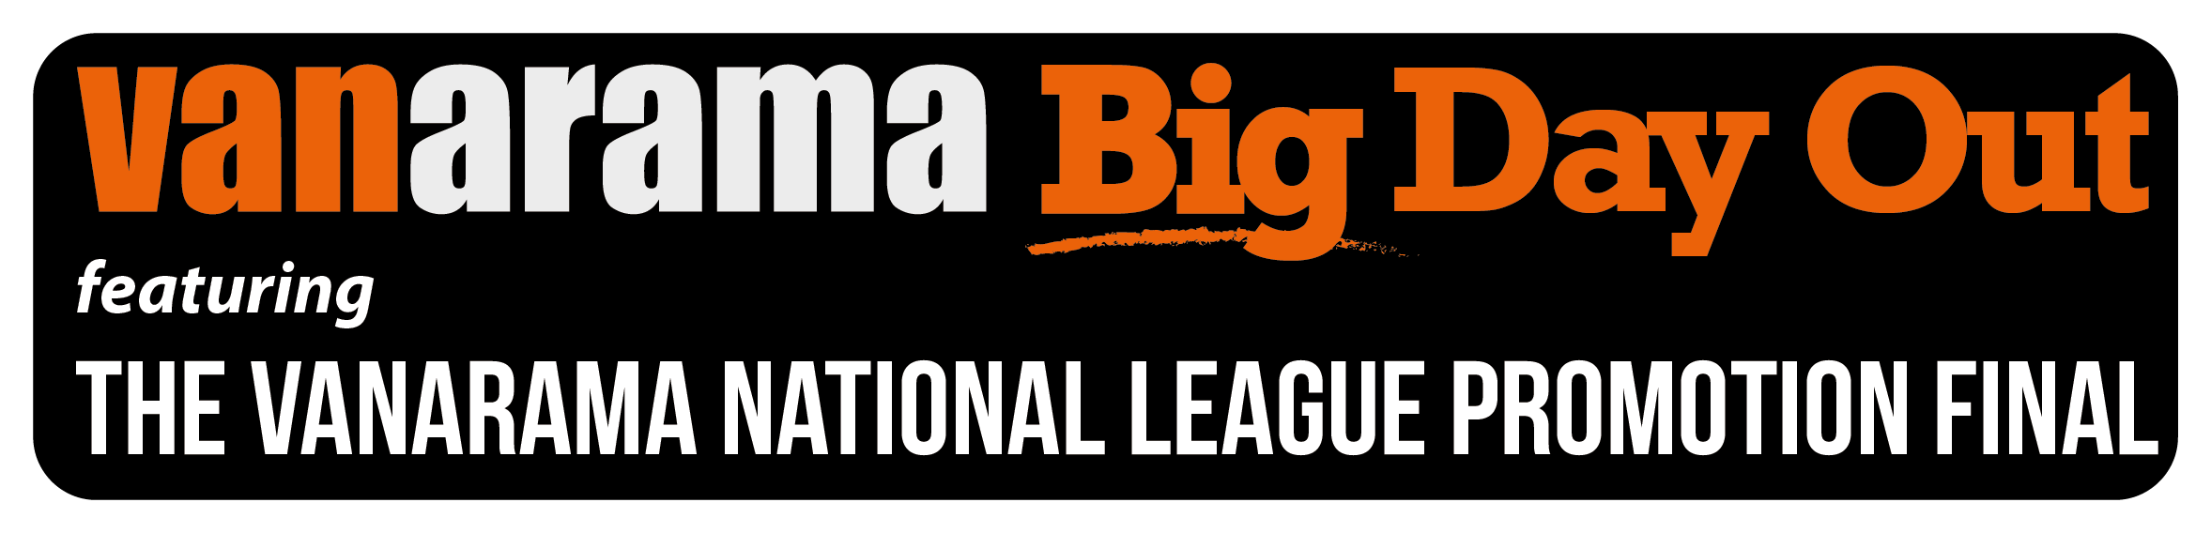

The National League (in association with sponsors Vanarama) has released details of ticket information for their annual flagship final at Wembley Stadium connected by EE which will kick off at 4pm on Sunday 15th May 2016.

This year ALL ticket sales will be handled directly by Wembley Stadium and will be available for the first time with an option for 'Print at Home' (PAH).

Tickets will ONLY be available to purchase on-line and are priced as follows:

EARLY BIRD - up to and including 31st March:
Adults: £20
Seniors (Over 60): £10
Under 16: FREE **
(** 1 free U16 ticket can be ordered for each ticket sold at Adult or Senior price).
Additional tickets for Under 16 over the above allowance can be purchased at £5 each.

Early Bird sales are made even more attractive as no booking fee is charged.
Please be advised no ticket is refundable once purchased.

Disabled seated allocation is available directly through Wembley Stadium and details are also available on-line.

GENERAL ADMISSION SALE - date available to be announced:
Category 1: £41 (no concessions)
Category 2: £36 and £18 (Under 16's)
These ticket sales will be subject to a booking fee.

For both General Admission and Early Bird sales, postage will be charged at:
£2.50 per order or £1 for all PAH sales.

Click WEMBLEY TICKET PORTAL to book your tickets

Note:
Early Bird tickets will NOT be available to purchasers either by post or available via PAH until the two competing finalist clubs are confirmed. This will allow for seated allocation to be made in blocks for any group of supporters of a club wishing to be in the same area.

In order for this to be offered, when on-line transactions are made the purchaser will be required to nominate which National League member club they align themselves to or they may indicate a ‘No Preference’ option.

Supporters of the two clubs reaching the Promotion Final will be allocated their tickets for the correct area of the stadium allotted to each finalist club.

Ends/.......

